* Right click on ocean-lbg (check below screen shot) and select Reset

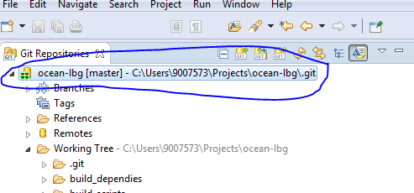

* Select origin/master under remote tracking. (check below screen shot)
* Check Hard
* Click on Reset

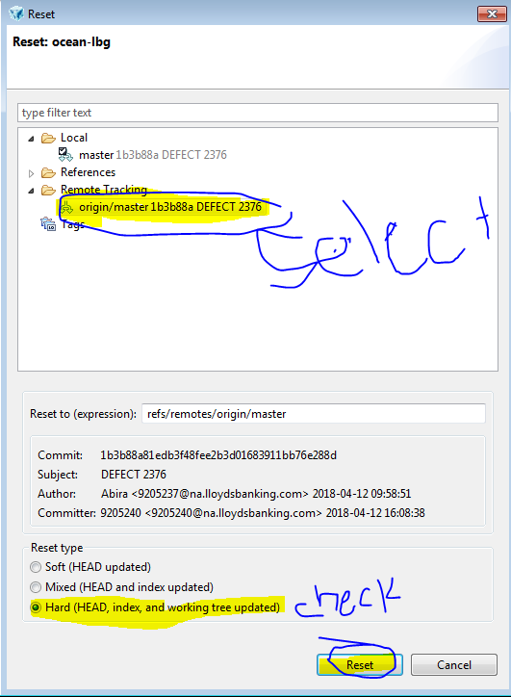

* Click yes on popup window (check below screen shot)

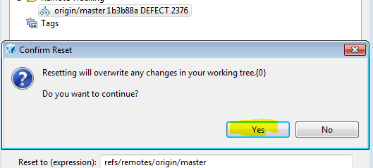

* Right click on ocean-lbg (check below screen shot) and select Reset



* Select HEAD under Reference. (check below screen shot)
* Check Hard
* Click on Reset

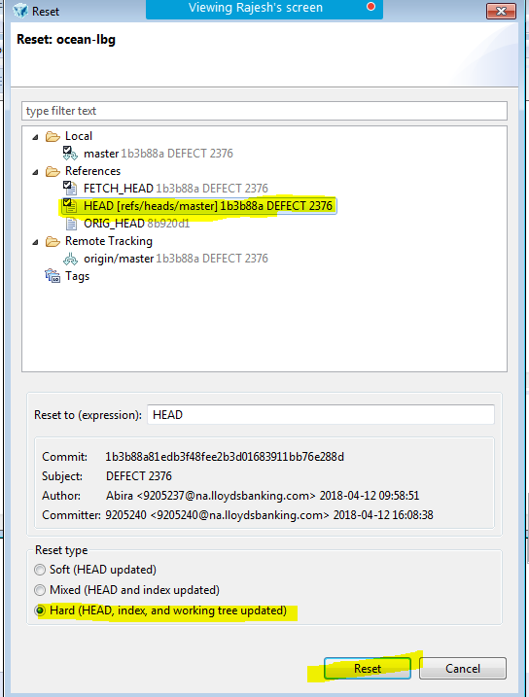

* Click yes on popup window (check below screen shot)



* Right click on ocean-lbg (check below screen shot) and select Clean



* Select files which you don’t want. Then click finish and click ok if pop window display.
* Otherwise cancel

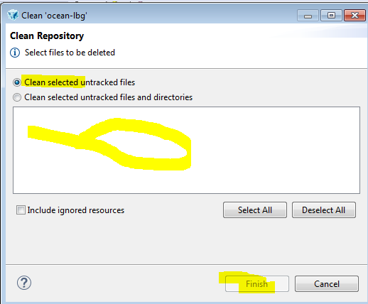

1. Right click on ocean-lbg (check below screen shot) and select Fetch From Upstream



1. Right click on ocean-lbg (check below screen shot) and select Rebase...



* Select origin/master and click on Rebase
* Click on Ok on popup window

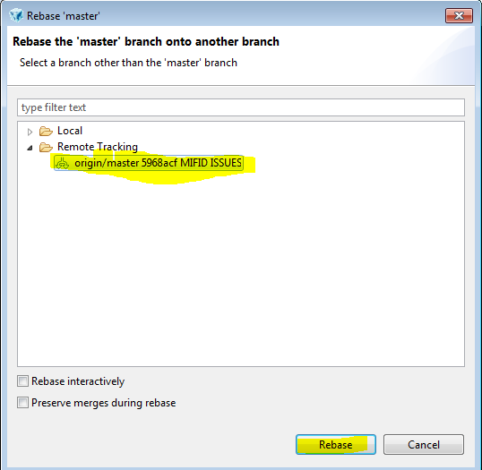

Double click on origin/dev_branch and select Checkout as new Local Branch on pop window (see below screen shot)

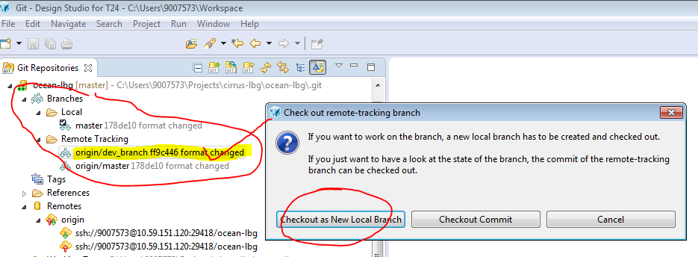

Then click on Finish

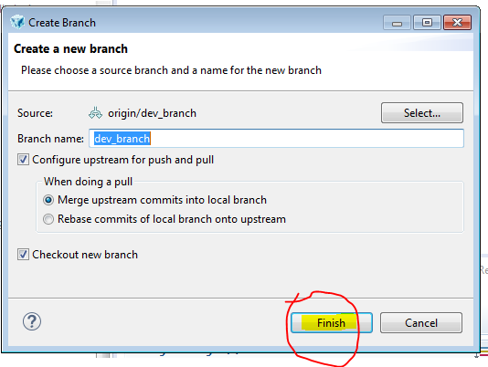

Now you can find Tick mark on dev_branch (check below screen shot)

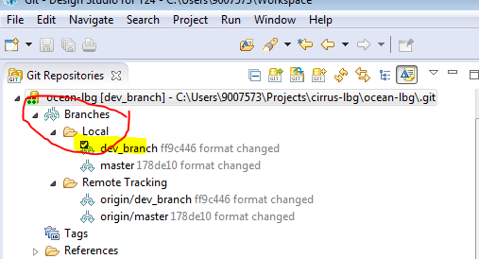

While pushing routines to Gerrit, cross check the branch name (see below screen shot)

You can see below window after clicking commit and push button.

